Name: pasala prasanna

Mobile no: 7989405181
e-mail ID: pasalaprasanna72@gmail.com
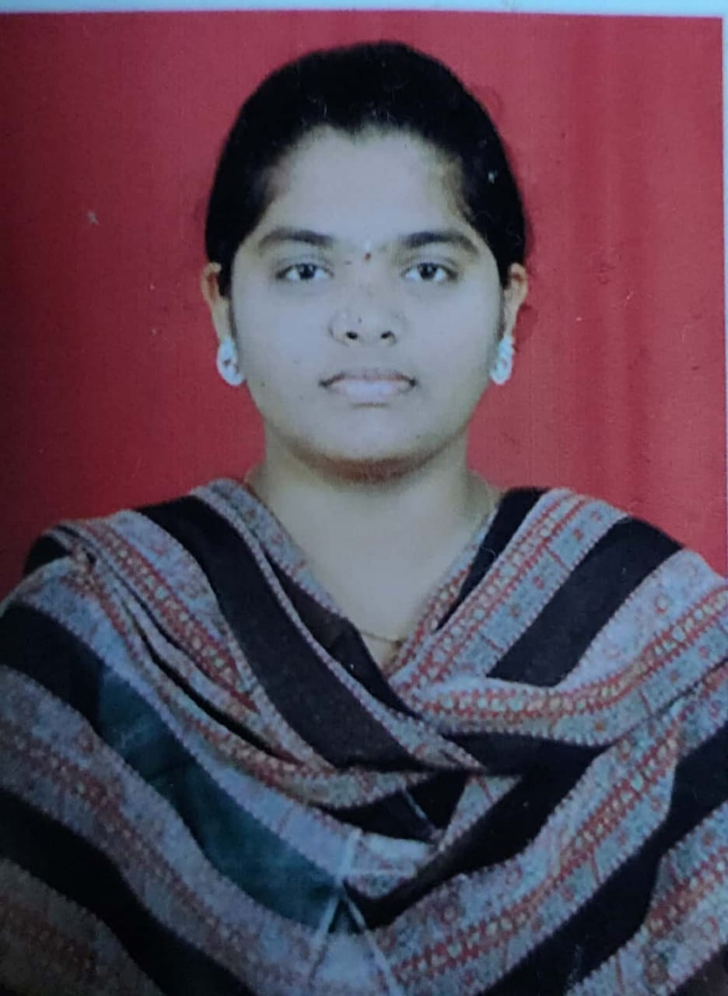

Career Objective:
To secure an entry level position in a professional company where I can learn and develop my skills while assisting the company in their professional efforts to the best of my abilities with a devoted and trustworthy attitude
Academic Background:
Qualification | College/school | University/board | Year | Percentage
B. Tech (Electronics and communication engineering) | Sri Venkateshwara college of engineering and technology, Chittoor | JNTU  Anantapur | 2017-2021 | 8.0(CGPA-till date)
Intermediate | Sri Chaitanya girl’s junior college, Tirupati | Board of intermediate education | 2015-2017 | 92.5
Ssc | S. p. z. p girl’s high school | Board of secondary education | 2015 | 8.7(GPA)

Area of Interest:

Programming languages.: -Basics of C and PYTHON

Strengths:
Decision making, honesty, self-control
Ability to cope up at any different situations.

Co-Curricular Activities:
Participated in a paper presentation on Applications of Internet of Things (IOT) which was held by SV University College on behalf of e-blaze event.
Extra-Curricular Activities:
Participated in cultural activities from childhood onwards.
Hobbies:
Listening and singing songs(melodies), painting, putting rangoli, google searching.
Personal Details:
Date of Birth : 29 July 2000
Languages known : Telugu, English, Tamil
Father’s Name : Pasala Krishnaiah
Permanent Address : D no: 3-45, P.N Road, Chandragiri, Chittoor district

Date: 25-09-20
Place: Chittoor (Pasala Prasanna)

